**How to replicate SD card:**

1. Insert SD card containing configured OS in the card reader.
2. Open Win32DiskImager [[Download link]](https://sourceforge.net/projects/win32diskimager/)

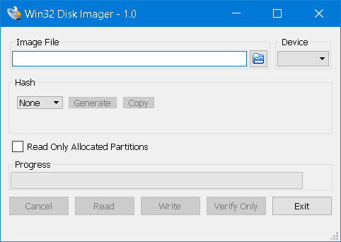

1. Select the path for the Image file i.e. select folder and file name in Image File field.
2. In device select the drive alphabet for SD card.
3. Click Read.
4. After read is complete insert the new SD card (in FAT32 format).
5. Select the path to the newly created image.
6. Select Device.
7. Click write.

**How to setup using pre-configured SD-card (which we replicated in above section):**

1. Insert the SD card in pi, give it power and connect it to laptop using LAN cable.
2. In network and sharing, select **wireless network (not ethernet)** -> Sharing -> check the “Allow other users” checkbox and select “LAN” in the drop down.
3. Now open command prompt and execute command $arp-a$, note down the IP address under interface 192.168.137.1 i.e. 192.167.137.* (except 192.167.137.255 as this is broadcast).
4. Now open VNC viewer [[Download link](https://www.realvnc.com/en/connect/download/viewer/)], and in it enter the IP address that we copied in the above step.
5. Connect it and enter credentials, [credentials for Harshit’s server image is **Username:** pi **Password:** raspberry].

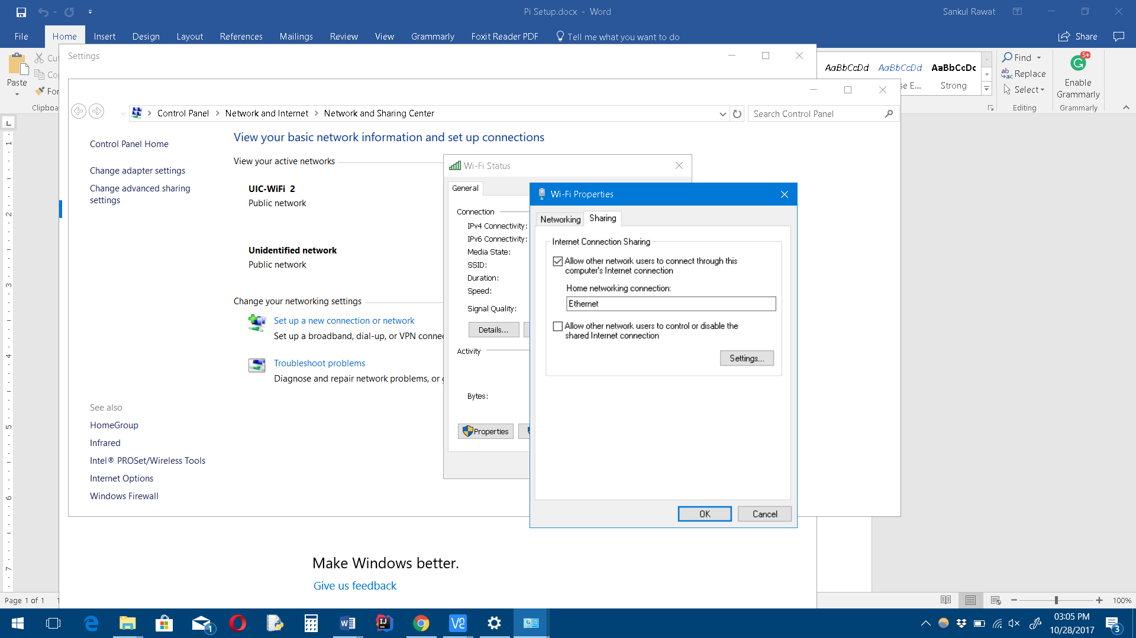

1. Now your interface